Pengantar SQL

Worksheet 1

NIM : -

Nama : Yohan Dwi Bachtiar

Kelas : FDW

SOAL

**ERD dbpos**

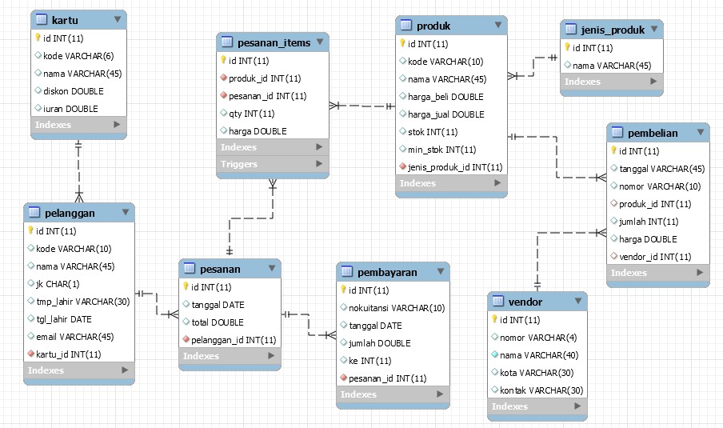

Berdasarkan ERD dbpos, buatlah tabel-tabel pada ERD menggunakan perintah SQL DDL.

//query dibawah untuk membuat database baru

**MariaDB [(none)]> CREATE database dbpos;**

// query dibawah ini untuk menggunakan dtabase

**MariaDB [(none)]> USE dbpos;**

*Jawaban perintah SQL nya dimasukan disini, contoh:*

*CREATE TABLE kartu (*

*id integer auto_increment primary key,*

*kode varchar(4) unique,*

*nama varchar(30) not null,*

*diskon double default 0,*

*iuran double default 0*

*);*

Langkah – Langkah Praktikum pertemuan ke-5 minggu ke-6 Perkuliahan

Membuat Database dan table yang berelasi

1. **Buat database**

MariaDB [(none)]> create database dbpos;

1. **Gunakan Database dbpos**

MariaDB [(none)]> use dbpos;

1. **Buat table kartu**

MariaDB [dbpos]> create table kartu(

-> id int auto_increment primary key,

-> kode varchar(6) unique,

-> nama varchar(30) not null,

-> diskon double,

-> iuran double);

1. **Buat table pelanggan**

MariaDB [dbpos]> create table pelanggan(

-> id int auto_increment primary key,

-> kode varchar(10) unique,

-> nama varchar(45),

-> jk char(1),

-> tmp_lahir varchar(30),

-> tgl_lahir date,

-> email varchar(45),

-> kartu_id int not null references kartu(id));

1. **Buat table pesanan**

MariaDB [dbpos]> create table pesanan(

-> id int not null auto_increment primary key,

-> tanggal date,

-> total double,

-> pelanggan_id int not null references pelanggan(id));

1. **Buat table Pembayaran**

MariaDB [dbpos]> create table pembayaran(

-> id int not null auto_increment primary key,

-> nokuitansi varchar(10) unique,

-> tanggal date,

-> jumlah double,

-> ke int,

-> pesanan_id int not null references pesanan(id));

1. **Buat table Jenis_produk**

MariaDB [dbpos]> create table jenis_produk(

-> id int not null auto_increment primary key,

-> nama varchar(45));

**Tugas Mandiri**

1. **Buat table produk**
2. **Buat table pesanan_items**
3. **Buat table vendor**
4. **Buat table Pembelian**

**--Menambahkan Data Pelanggan--**

**INSERT INTO `pelanggan` (`id`, `kode`, `nama`, `jk`, `tmp_lahir`, `tgl_lahir`, `email`, `kartu_id`) VALUES (NULL, 'C002', 'Mukidi', 'L', 'Solo', '2017-10-11', 'mukidi@gmail.com', ''), (NULL, 'C003', 'Jono', 'L', 'Yogyakarta', '2018-10-10', 'APW@gmail.com', ''), (NULL, 'C004', 'Suki', 'L', 'Konoha', '2014-10-08', 'Suki@gmail.com', ''), (NULL, 'C005', 'Suka', 'P', 'Malang', '2015-10-09', 'Suka@gmail.com', ''), (NULL, 'C006', 'Gumbrek', 'L', 'Jombang', '2013-10-02', 'Gumbrek@gmail.com', ''), (NULL, 'C007', 'Ponirah', 'P', 'Blitar', '2013-10-16', 'Ponirah@gmail.com', ''), (NULL, 'C008', 'Misni', 'L', 'Blitar', '2014-10-01', 'Misni@gmail.com', ''), (NULL, 'C009', 'Hana', 'P', 'Surabaya', '2016-10-03', 'Hana@gmail.com', ''), (NULL, 'C010', 'Hani', 'P', 'Surabaya', '2023-10-06', 'Hani@gmail.com', ''), (NULL, 'C011', 'Hono', 'L', 'Malang', '2023-11-10', 'Hono@gmail.com', ''), (NULL, 'C012', 'Hini', 'P', 'Surabaya', '2018-10-09', 'Hini@gmail.com', ''), (NULL, 'C013', 'Hunu', 'L', 'Malang', '2017-10-04', 'Hunu@gmail.com', ''), (NULL, 'C014', 'Hene', 'L', 'Malang', '2014-10-07', 'Hene@gmail.com', ''), (NULL, 'C015', 'Zilong', 'L', 'Moba', '2017-10-17', 'Zilong@gmail.com', ''), (NULL, 'C016', 'Hitler', 'L', 'Djakarta', '2014-10-08', 'Hitler@gmail.com', '');**

**--Menambahkan Data Produk--**

**INSERT INTO `produk` (`id`, `kode`, `nama`, `harga_beli`, `harga_jual`, `stok`, `min_stok`, `jenis_produk_id`) VALUES (NULL, 'TK01', 'Teh Kotak 100Ml', '1000', '1500', '8', '2', '4'), (NULL, 'TK02', 'Teh Kotak 500Ml', '5000', '6000', '80', '5', '4'), (NULL, 'KR01', 'Kursi Lipat', '80000', '90000', '100', '5', '2'), (NULL, 'MJ01', 'Meja 4x4', '85000', '90000', '100', '4', '2'), (NULL, 'SF01', 'SeaFood Cumi', '50000', '60000', '80', '5', '3'), (NULL, 'SF02', 'SeaFood Kepiting', '60000', '70000', '80', '5', '3'), (NULL, 'SF03', 'SeaFood Baby Crab', '40000', '50000', '80', '5', '3'), (NULL, 'A01', 'Ayam Potong Goreng', '8000', '9000', '2000', '5', '3'), (NULL, 'A02', 'Ayam Kampung Goreng', '8000', '10000', '50', '5', '3'), (NULL, 'A03', 'Ayam Horen Goreng', '9000', '10000', '60', '5', '3'), (NULL, 'HW01', 'Mouse Gamming', '90000', '110000', '50', '5', '5'), (NULL, 'HW02', 'Monitor 24 Inch Lexus', '6000000', '6500000', '50', '5', '5'), (NULL, 'HW03', 'Keyboard Gaming', '200000', '250000', '50', '3', '5'), (NULL, 'HW04', 'SSD 500Gb Mideaforce', '800000', '900000', '80', '5', '5'), (NULL, 'HW05', 'RAM 16BG DDR4 V-Genn', '600000', '650000', '60', '5', '5');**

**--Menambahkan Tabel Vendor--**

**MySQL returned an empty result set (i.e. zero rows). (Query took 0.0007 seconds.)**

**CREATE TABLE vendor( id int not null AUTO_INCREMENT PRIMARY KEY, nomor varchar(4), nama varchar(40), kota Varchar(30), kontak varchar(30));**

**--Membuat Tabel Pembelian--**

**MySQL returned an empty result set (i.e. zero rows). (Query took 0.0006 seconds.)**

**CREATE TABLE pembelian( id int not null AUTO_INCREMENT PRIMARY KEY, tanggal Varchar(45), nomor Varchar(10), produk_id int, jumlah int, harga double, vendor_id int);**